PROJECT MANAGEMENT OF AFFORDABLE HOUSING UNIT CONSTRUCTION IN THE SAN FRANCISCO BAY AREA

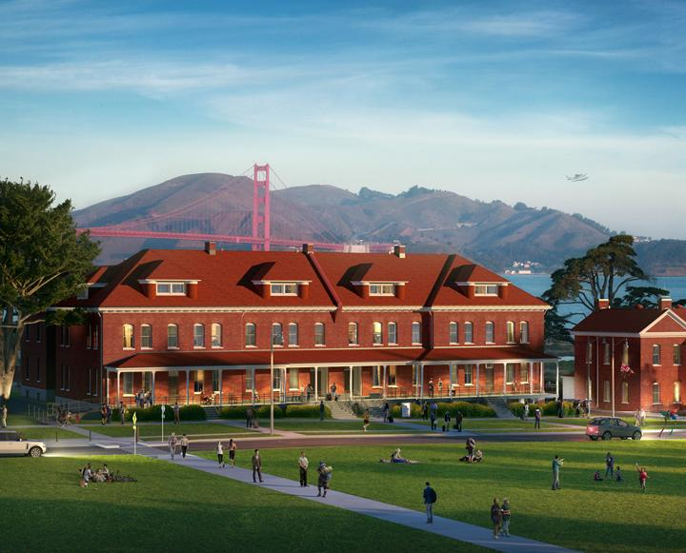

MGMT 658 - Final Report

October 2020

Analysts: Christian Rodriguez | Flora Wong | Jeff Estrellanes | Patricia Ligon | Nancy Yuen | Gyati Mittal | Ankitaben Patel | Anshika Sharma

Table of Contents

**Introduction - Background/Overview** **4**

Project Scope 5

Project Objective 5

Deliverables 5

Milestones 5

Technical Requirements 6

Limits and Exclusions 6

Reviews with Customer 6

**Project Planning** **7**

Project Organization Chart 7

Project Resources 8

Labor resources 8

Material resources 8

Additional fixed cost resources 8

WBS design and OBS design 10

Work Breakdown Structure (WBS): Diagram 10

Work Breakdown Structure (WBS): Diagram (Zoomed up) 11

WBS with Predecessors 12

WBS with Gantt Chart 13

Gantt Chart 14

WBS with (ES), (EF), (LS), (LF), Slacks 15

Network Diagram 16

Critical Path 18

Natural Disaster Impact On WBS 21

WBS after Natural Disaster Impact 23

Gantt Chart after Natural Disaster Impact 25

Network Diagram after Natural Disaster 26

Critical Path after Natural Disaster 27

Project Cost Analysis and Budgeting 28

Single unit budget 28

Schedule resource allocation planned cost 28

Project Scheduling and Stakeholders 31

Stakeholders 31

Project Schedule and Time Frame 33

Timeline before natural disaster (Earthquake) occurred: 33

New timeline after Natural Disaster with crashing activities: 34

**Project Executing** **35**

Technical Challenges 35

Bureaucratic Challenges 35

Environmental Challenges 35

Space Issues 35

Crime Issues 35

Unsuitable Areas 35

Commute Challenges 36

Risk Management: Scenarios & Risks 37

Numerical Scale 37

Initial Risk Assessment Form 38

Underground Secrets 39

Risk Assessment Form - Post-cavern / fault discovery 40

Risk Response Outline 41

Risk Severity Matrix 41

Contingency Plan Activation: Plan Delta 42

Plan Delta Executive Summary 43

Contingency Considerations and Estimated Impacts 44

A Sleeping Earth Awakens 45

Reducing Project Duration (Project Crashing) 46

Lessons Learned 50

What did we do well? 50

What can we improve? 51

**Conclusion** **52**

**Bibliography** **53**

# Introduction - Background/Overview

The housing sector in the SF Bay Area is a priority for the state of California. Hence, the construction of low-cost single family houses and large-scale residential housing units is of the utmost importance. The local government is sanctioned to achieve the state housing goal of “Affordable Housing for The Bay by 2022.” This being the case, local bay area cities are offering budgetary support and incentivizing agencies to help in promoting expedited housing development in the region for the low-income market segment.

Our team of California State University East Bay MBA graduates and fellow entrepreneurs have decided to take on a major project which involved the development of multi-housing low income units in Hayward, CA. The development of the first unit of the project was set to begin on Friday, January 1, 2021 and initially scheduled for completion on Thursday, August 5, 2021. This project focuses on the construction of the first model unit in the multi-unit property. The project required the team to develop a “work breakdown structure” which could be used in order to develop an understanding of the major deliverables and sub-deliverables, duration per task, and to provide a general understanding of what the time frame would be in order for the project to be completed. In essence, the development of the work breakdown structure allowed the team to maintain a network for planning, scheduling, and monitoring project progress.

In addition to the development of a work breakdown structure, the utilization of “Microsoft Project” allowed the team to develop a Gantt chart which clearly illustrated the “critical path” of the project. A Gantt chart is a two-dimensional time scale horizon of the project schedule with activities down the rows and time across the horizontal axis. They are used during planning, resource scheduling, and status reporting (Larson & Gray, 2018, p. 179). Approximately 5 months into the project the SF Bay Area had experienced a 7.7 magnitude earthquake which created significant setbacks to the overall timeline. Prior to the initial development of the affordable housing units, the team had developed a “contingency plan” as we understood that the Hayward fault was close and provided the potential for a risk event to occur during the development process. The implementation of the contingency plan helped to reduce the overall effect that the earthquake had on the project timeline.

The following report will demonstrate how the CSUEB team utilized advanced project management techniques to achieve the state housing goal of developing “Affordable Housing for the Bay by 2022” from inception to completion.

## Project Scope

### Project Objective

CSUEB MBA students to manage and construct affordable housing units in the San Francisco Bay Area. The first sample housing should be completed by September 1, 2021 at a cost that does not exceed $500K.

### Deliverables

The below are a list of specifications representing the major deliverables that are expected outputs over the life of the project.

* Provide service blueprint for a 1852 square foot by February 16, 2021
* House to include kitchen appliances such as range oven, stove, dishwasher, refrigerator. To meet the targeted deadline, these should be installed by 7/26/2021
* Outdoor landscaping should be completed 7/28/2021
* House should be build with earthquake proof material to mitigate the amount of damage if an earthquake occurs

### Milestones

Below are the main task that are needed to get the project moving forward and hitting our milestones

|  |  |
| --- | --- |
| **Milestones** | **Completion Date** |
| Service Blueprint | 2/16/2021 |
| Zoning Approval | 4/20/2021 |
| Carpentry | 5/14/2021 |
| Plumbing | 7/6/2021 |
| Inspection | 8/4/2021 |
| Reflection, Lesson Learned | 8/5/2021 |

### Technical Requirements

* Units must meet California’s building codes of safety
* Landscape must be completed
* For energy efficient, doors and windows must meet the requirements of Energy Star Program
* Structure must pass seismic stability codes.

### Limits and Exclusions

* The units to be built to the specifications and design of the original blueprints submitted to the city for approval.
* Normal working hours: 8 AM to 5 PM, M-F, if overtime is required, approval is needed

### Reviews with Customer

After the project is completed. The city would need to do a walk through for the final inspection, making sure the house is up to code. Once the house is approved, the house is good to sell. The CSUEB team would need to complete a reflection on the project and find out what lessons are learned while doing the project. After completing this house, there would be more affordable units to build in the city of Hayward, CA.

# Project Planning

## Project Organization Chart

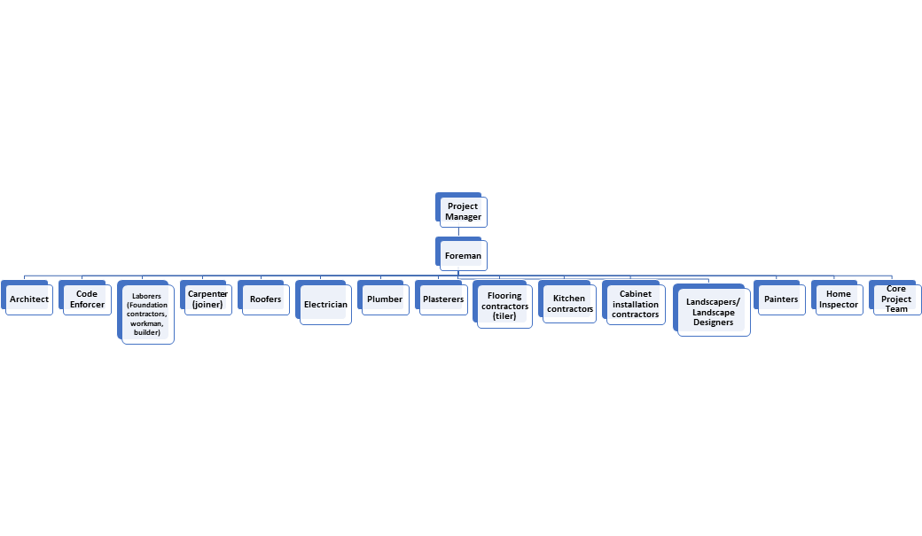

*Figure 1. Project Organization Chart (*[*larger view*](https://drive.google.com/file/d/1iniKwjYZ-VLLrWO-6hfTJrrJEJFU2n7R/view?usp=sharing)*)*

The project organization chart is a visual diagram of our project team. It shows a hierarchy between team members. Our project manager oversees and monitors and controls the timelines. Then we have the foreman who is in charge of a group of workers in different departments performing their tasks.

## Project Resources

### Labor resources

For the construction of the multi unit affordable housing complex we will focus on the project resources of one model home built to completion. The project team will consist of a single project manager, foreman, architect, 15 full time laborers dedicated to the project working a standard work week Monday through Friday during the hours of 8 am to 5 pm. In addition, to 5 part time laborers available to work 4-6 hours within the established project working hours. The time unit of days should be used through the project.

### Material resources

Resources in this classification have been specified by price per square foot or quantity. Figure 2 shows the breakdown of the resources.

### Additional fixed cost resources

Subcontractors, permit fees, and inspection fees are included in this classification. Detailed resources and planned cost references can be found in figure 2.

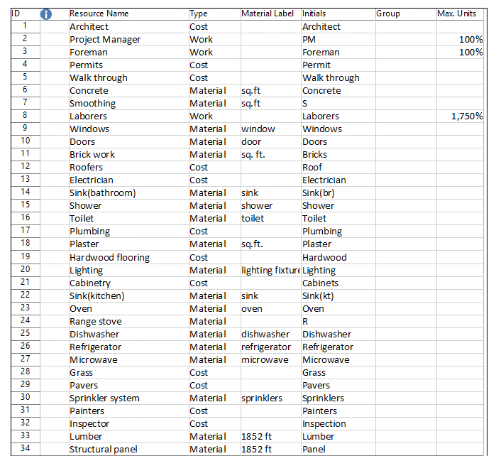

*Figure 2. Project Resource*

## WBS design and OBS design

### Work Breakdown Structure (WBS): Diagram

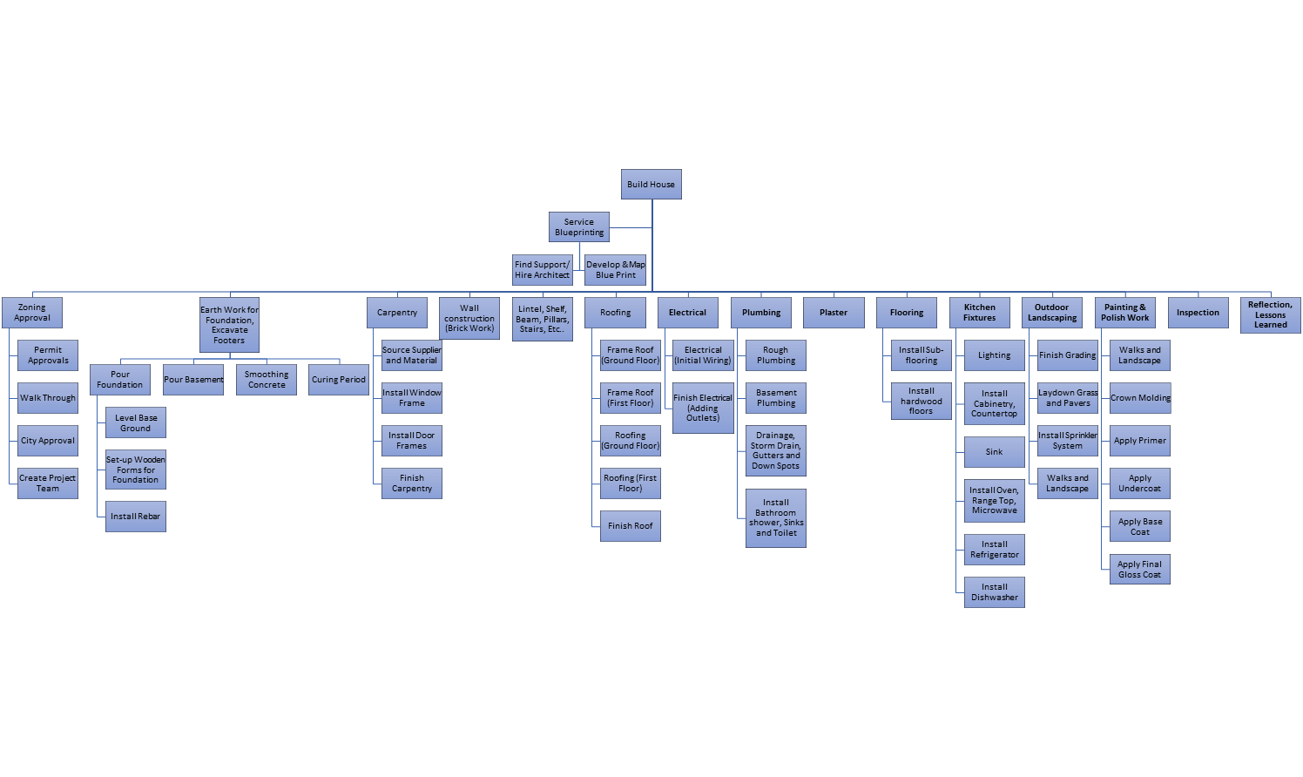

*Figure 3. WBS Structure Breakdown (*[*larger view*](https://drive.google.com/file/d/1cA6FHs7D-n-W5IsgF_nXZ2eWh6CjY28Q/view?usp=sharing)*)*

### Work Breakdown Structure (WBS): Diagram (Zoomed up)

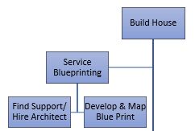

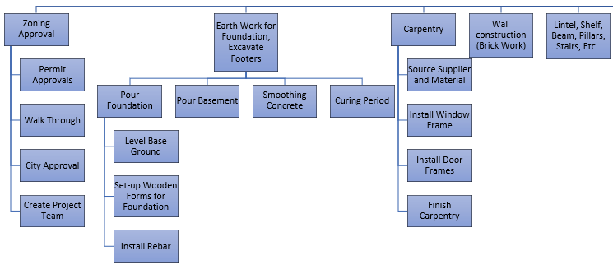



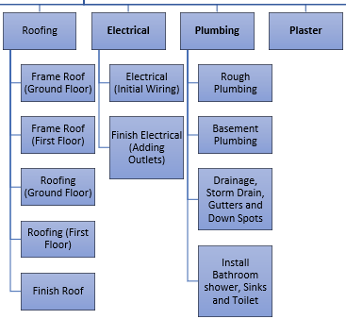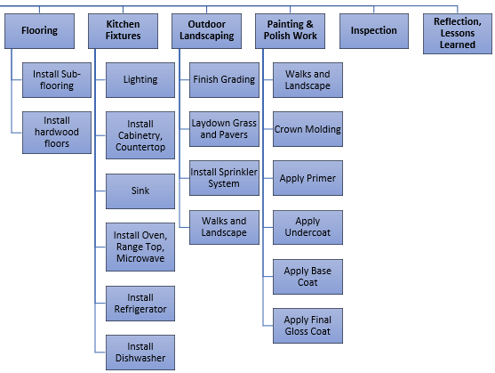

*Figure 4. WBS Structure Breakdown (Zoomed) (*[*larger view*](https://drive.google.com/file/d/1cA6FHs7D-n-W5IsgF_nXZ2eWh6CjY28Q/view?usp=sharing)*)*

The WBS diagram shows all the deliverables and sub-deliverables that need to be completed for the project.

### WBS with Predecessors

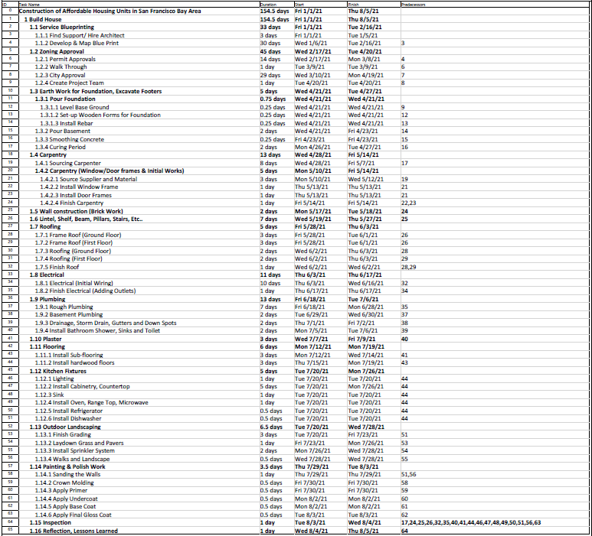

*Figure 5. WBS with Predecessors (*[*larger view*](https://drive.google.com/file/d/1-1bXetajioOJPpEkxB380OJaXeK9pk3K/view?usp=sharing)*)*

In the work breakdown structure (WBS), most of the activities are conducted from finish to start. For example, we have to purchase the material, before starting some of these activities. Some of these activities have predecessors, so it must be completed in a certain order, for example you must have a blueprint created, before getting your permits approved. We also have some activities that we revised to be parallel by using start-to-finish relationships, also known as concurrent engineering, to compress the duration and critical paths. While other activities can be done in parallel, like kitchen fixtures. There can be different workers installing lighting, cabinetry and countertops, a sink, oven, range top, microwave, refrigerator, and dishwasher all on the same day. Our project also consists of some Hammock activities like inspection services, consultants (architech) or construction management services (carpenter, electrician, and workers).

### WBS with Gantt Chart

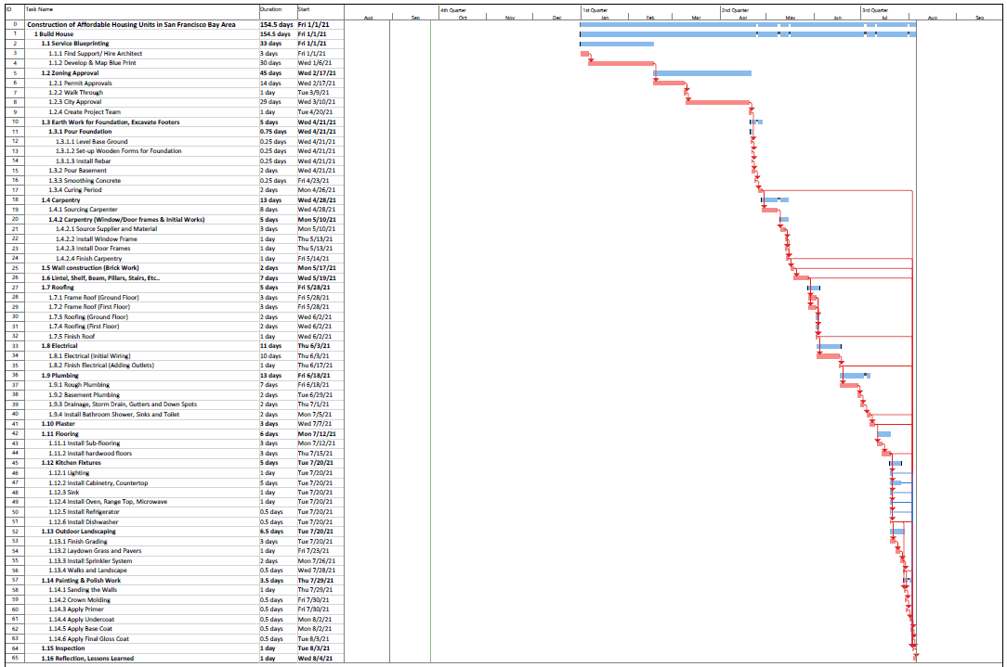

*Figure 6. WBS with Gantt Chart (*[*larger view*](https://drive.google.com/file/d/1sB2W4sLq8rFaFap75_qZqImSQ490Lj77/view?usp=sharing)*)*

The activities highlighted in red on the gantt chart are the critical path activities. Since this is a time-constrained project, we had to smooth our resource demand.

### Gantt Chart

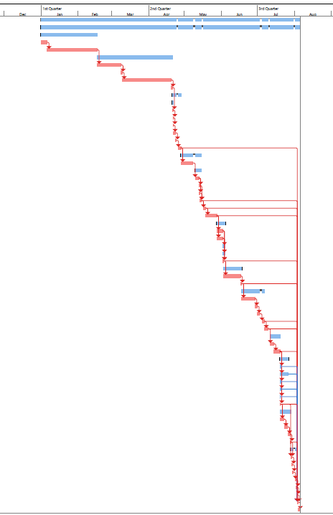

*Figure 7. Gantt Chart (*[*larger view*](https://drive.google.com/file/d/1pcdc-XZ9eV_yGIvW0xALL7_Spd34O6TF/view?usp=sharing)*)*

### WBS with (ES), (EF), (LS), (LF), Slacks

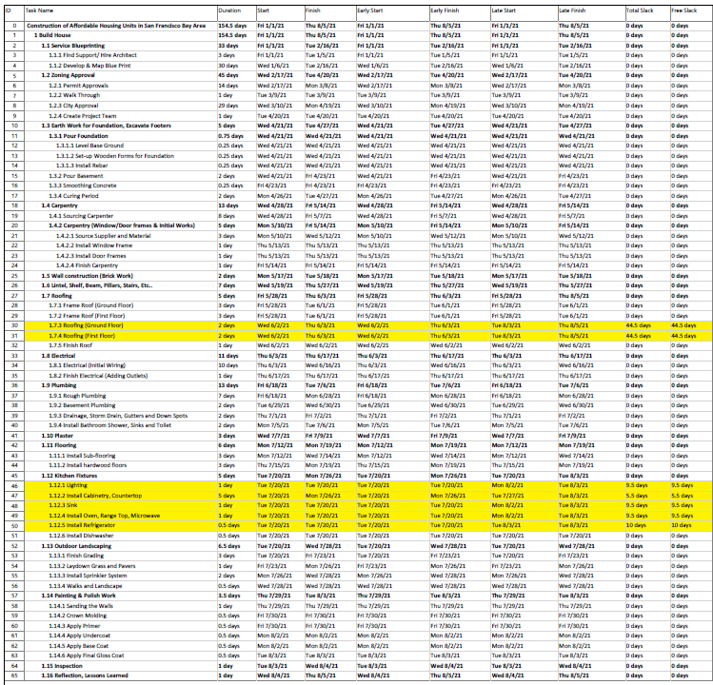

*Figure 8. WBS with (ES), (EF), (LS), (LF), Slacks (*[*larger view*](https://drive.google.com/file/d/1IeUPsiqjLN32cvL9SuzM0_OK5SIhyaOs/view?usp=sharing)*)*

If there are zero days for slack, then it is a critical path activity. In our WBS, we have several non-critical activities which contain some free slack/ total slack, like roofing (ground floor), roofing (first floor), and installing cabinetry, countertop, sink, oven, range top, microwave, and refrigerator. This gives us some buffer time, if some activities are delayed. Unfortunately, this project also has a lot of critical paths and activities, it is a sensitive network, so we have a very tight schedule. As a project team and project managers, we have to pay close attention to the critical path activities to be sure they are not delayed.

### Network Diagram

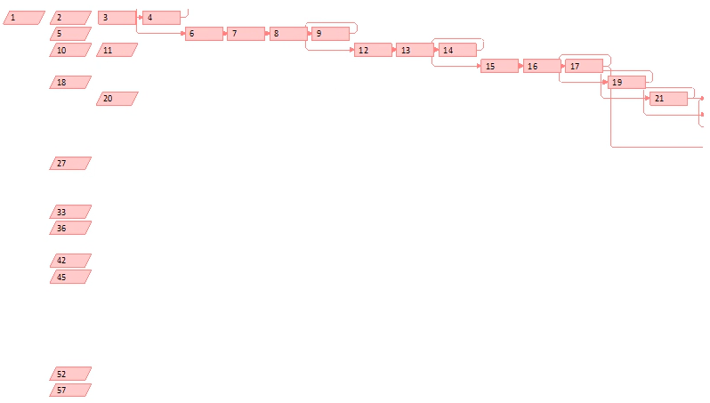

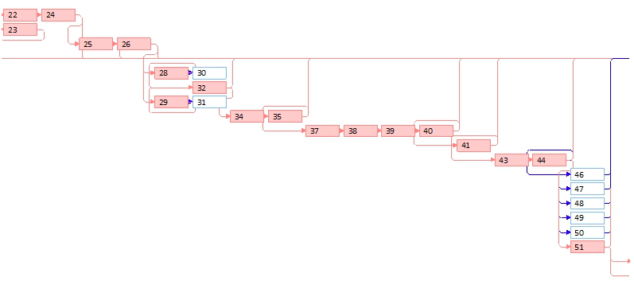

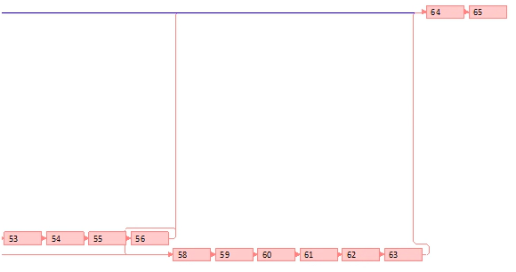

*Figure 9. Network Diagram*

### 

### Critical Path

List of Critical Path

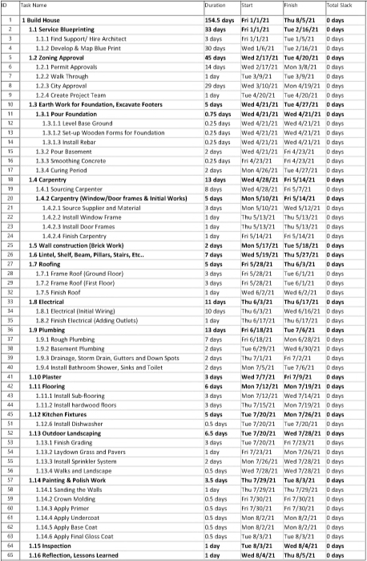

*Figure 10. List of Critical Path (*[*larger view*](https://drive.google.com/file/d/13PeWWJN6h9mlNd-n_PRZ_3_3NlXcFu6r/view?usp=sharing)*)*

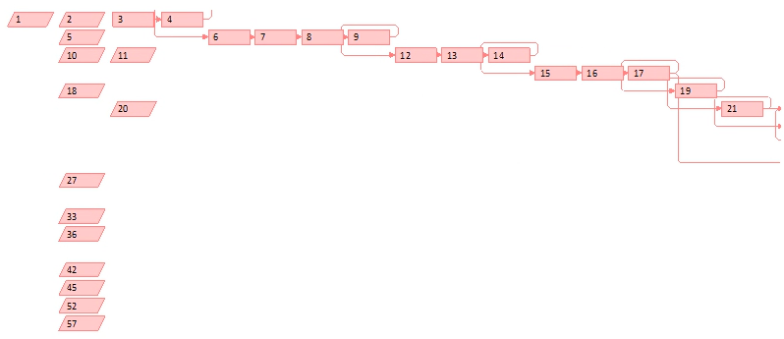

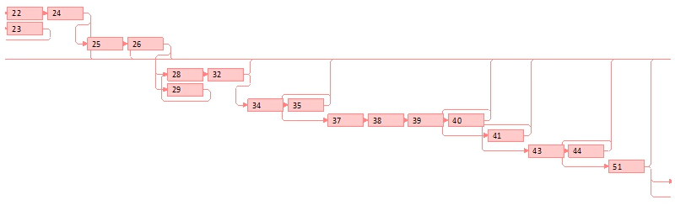

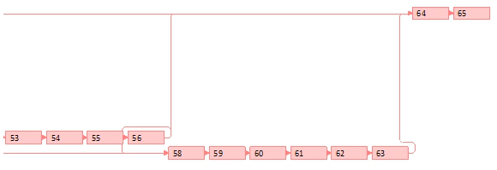

*Figure 11. Critical Path Diagram*

Figure 10 lists the critical path activities for the network diagram. The critical path have several critical paths as shown in Figure 11, with ID # 1, Build House, being the starting point of the project and merging together at ID # 64, Inspection, while ending with ID # 65, Reflection, Lesson Learned.

This critical path is considered to be a sensitive network as there are several critical paths throughout the whole project. Although ID # 30, Roofing Ground Floor and ID # 31, Roofing First Floor, of the non-critical activities have a larger slack time of 44.5 days, this project is still sensitive, given the fact that there are very few non-critical activities and multiple critical paths. For the CSUEB team to be on track for their construction of the sample affordable housing, we would need to pay close attention to all the critical activities to ensure that we do not delay the progress.

### Natural Disaster Impact On WBS

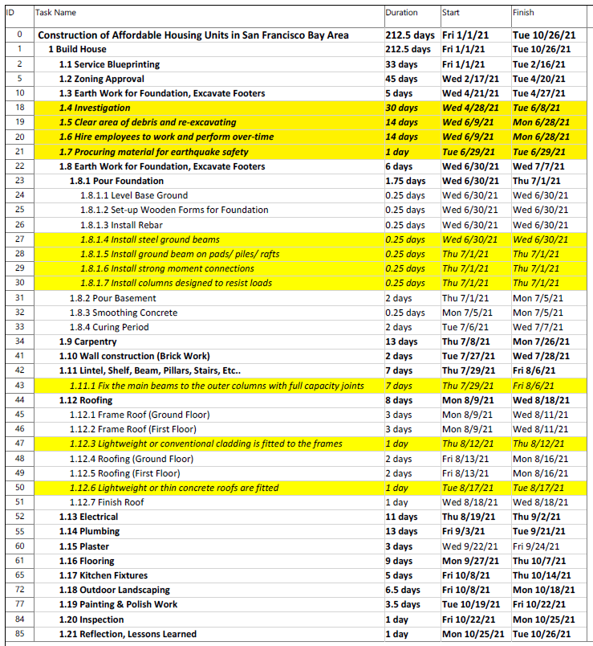

*Figure 12. Natural Disaster Impact On WBS (*[*larger view*](https://drive.google.com/file/d/1gw2uOygP8WCfT3YLp1RG8yossxGdXBvs/view?usp=sharing)*)*

The natural disaster impacted our project at the early stages of our project. As a team, we brainstormed and identified risks, analyzed the risks, and came up with solutions depending on project priorities, different kidneys of impacts (time, scope, quality), and our budget. We had to look at our timeline to see if we can create merget activities to have some free slack. We were able to have existing workers clear areas of debris and re-excavating, while hiring new employees to work and perform over-time. We had to decide if we wanted our employees to work overtime or on the weekends to complete the project faster.

The natural disaster impacted our timelines close to 3 months, due to investigation, clear area of debris and re-excavating, procure material to strengthen the building (like connection joints, and lightweight material to be fitted to frames and roofs designed to resist earthquake loads), hire employees, and rebuilding from step 1.3 Earth Work for Foundation, Excavate Footers with new earthquake safety in mind. We had to hire workers to work on the weekends to pull up the timeline.

To earthquake proof the building, we will be adding:

1. steel ground beams joining the feet together
2. ground beam may be built on pads or piles or rafts
3. strong moment connections
4. columns designed to resist loads in one direction and others in the other direction
5. fix the main beams to the outer columns with full capacity joints
6. floors are fitted
7. lightweight or conventional cladding is fitted to the frames
8. lightweight or thin concrete roofs are fitted

#### WBS after Natural Disaster Impact

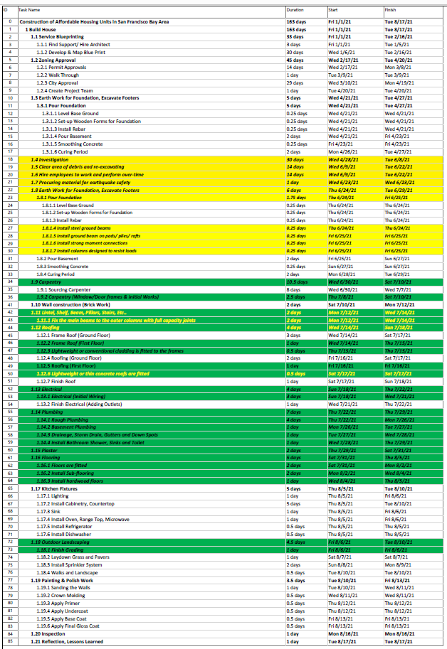

*Figure 13. WBS after Natural Disaster Impact (*[*larger view*](https://drive.google.com/file/d/1WLKqy8sznxvG0lziJGKAF3TttIy2sZS0/view?usp=sharing)*)*

After the Natural Disaster, we would need to incorporate earthquake safety design in the buildings (highlighted in yellow, or in yellow words). In order to meet the new deadline, weekend shifts were required starting with activity 19, 1.5 Clear area of debris and re-excavating. We also incorporated crashing activities to speed up our project (highlighted in green). The natural disaster caused an 82 days (2 months 3 weeks) delay in our timeline. We decided to fast track our project, by having workers work on the weekends and include some crashing activities, we were able to pull the schedule up by 70 days (2 months 1 week). This brought our project back on track.

#### Gantt Chart after Natural Disaster Impact

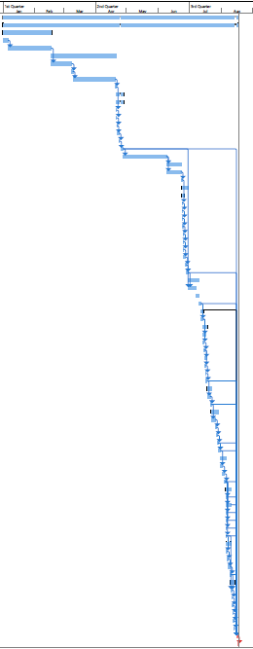

*Figure 14. Gantt Chart after Natural Disaster Impact (*[*larger view*](https://drive.google.com/file/d/18vCCfSdtaWfLRAYdwrOGgxQryHh7NDqG/view?usp=sharing)*)*

#### Network Diagram after Natural Disaster

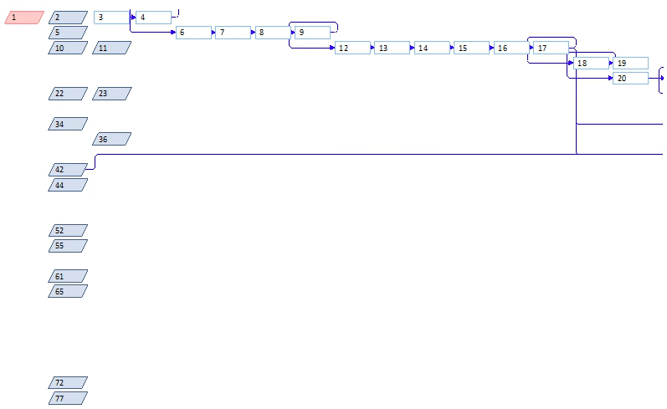

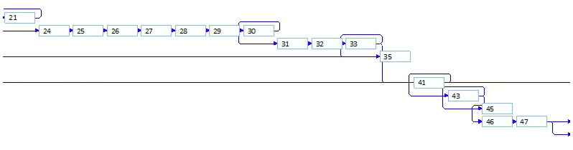

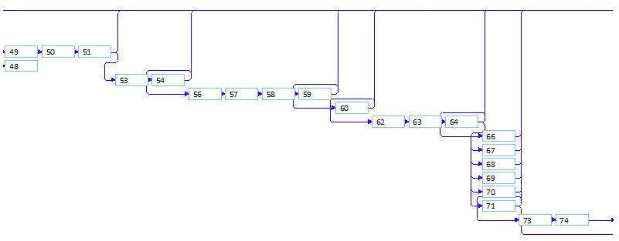

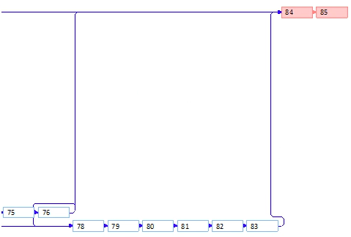

*Figure 15. Network Diagram after Natural Disaster*

#### Critical Path after Natural Disaster

## 

*Figure 16. Critical Path after Natural Disaster*

With the earthquake happening, in order to get back on track to meet our September 1, 2021 deadline, the team got together to analyze the project timeline. Some of the activities can be crashed to shorten the time frame. Weekend shifts were also added to help with the timeline. After crashing the project timeline and adding weekends shift, we were back on track; however, this changed our critical path. Instead of having a really tight schedule, we are now seeing more flexibility in the schedule and allow more slack times to complete each activity. The new critical path has only one path, with 3 activities. Starting point would be ID # 1 - Build House, moving to ID # 84 - Inspection, and ending with ID # 85 - Reflection, Lessons Learned. The critical path is now insensitive.

## Project Cost Analysis and Budgeting

### Single unit budget

The budget for a single housing unit was created using historical cost data from past housing development projects by scaling percentages to 1,852 sq.ft., the approximate square footage for one unit. All summary tasks were then apportioned by their unique weight and assigned a budget value. SMEs were consulted for additional cost estimates to meet unique challenges that may present due to the specific location of individual units and meeting compliance with local city code. The budgeted cost for one unit was estimated at $463,000 dollars given the time constraint.

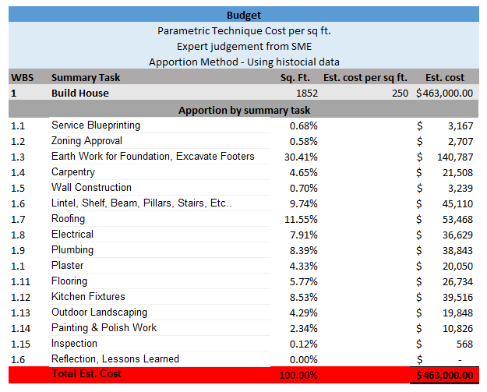

*Figure 17. Single Unit Budget (*[*larger view*](https://drive.google.com/file/d/1jrgg-iKdu3LzWzpyyqX6VhA7SVrjgmk6/view?usp=sharing))

### Schedule resource allocation planned cost

The gantt chart in Figure 17 shows the allocation of planned resources with their associated material cost, fixed cost and labor resource allocations for the critical path. Figure 17. shows the planned cost for completing approximately one 1852 sq. ft. unit. According to the schedule the completed planned cost for one unit is $404,448.28 **. Scheduled costs were under the initial budget estimated cost $463,000. References for cost estimates can be viewed [here](https://drive.google.com/file/d/16FKa1AmSyykIpJuDPUl3TaSM_da44gpF/view?usp=sharing).

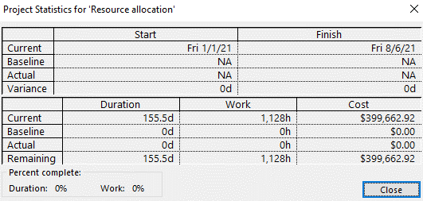

**Overhead is allocated using total direct labor hours, total billable hours (1016 billable hours at a rate of $4.71/hr) For a deeper look into planned cost review the scheduled cost breakdown.

*Figure 18. Project Statistics for ‘Resource Allocation’*

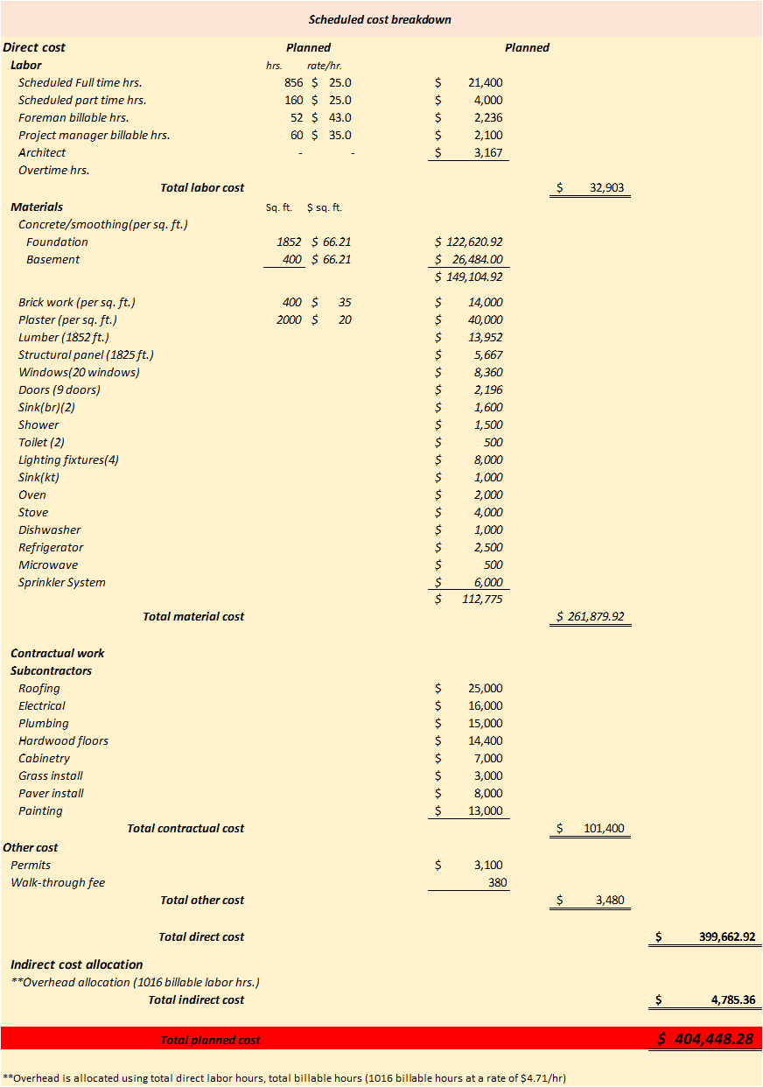

*Figure 19. Scheduled Cost Breakdown (*[*larger view*](https://drive.google.com/file/d/14c_NyBmSKh1gKCrOGG8_DwWD3WrkMxbQ/view?usp=sharing)*)*

## Project Scheduling and Stakeholders

### Stakeholders

The stakeholders of our construction project are those individuals or parties who are interested in, responsible for or impacted by our construction project. Stakeholders have interests in the successful completion of our project and are involved in various facets of the construction process. For work package details, please refer to the work breakdown schedule and project plan for further details. Below is an illustration of the various stakeholders in our project’s activities.

**List of Construction Stakeholders**



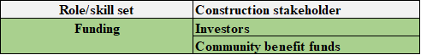

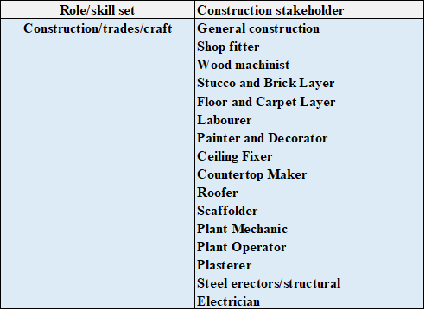

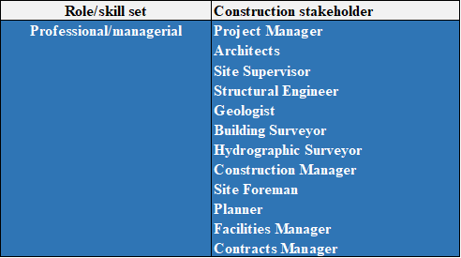

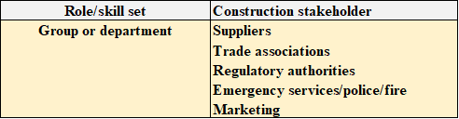

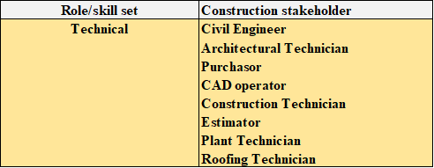

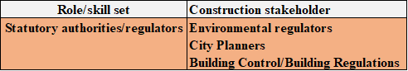

*Figure 20. List of Construction Stakeholders*

### Project Schedule and Time Frame

Every project follows a time frame that outlines start and end dates and milestones that must be met for the project to be completed on time. It consists of major tasks which have to be accomplished for the successful completion of it. These major tasks are actually each and every steps towards the success of the project. Likely, our project also consists of major tasks that are listed below along with the targeted finish date.

According to the deadline, the project schedule was designed to finish by August 05,2021. The first timeline represents the major tasks with a start and finish date before a natural disaster (under normal conditions).

Unfortunately, due to the occurrence of the natural disaster (earthquake) the finish date was pushed by around 3 months. To compensate for this delay, project crashing was introduced with a creation of a new timeline. So, according to the second timeline, the project completion date is August 17, 2021 which meets the deadline.

#### Timeline before natural disaster (Earthquake) occurred:

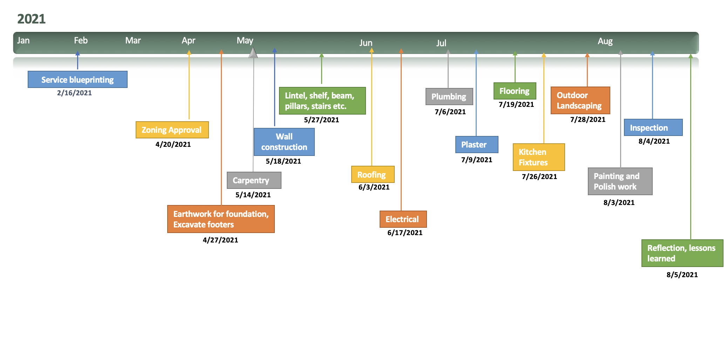

*Figure 21. Timeline Before Natural Disaster (*[*larger view*](https://drive.google.com/file/d/1sMNp2DAxK_Mxrza8NMMClqS3EWioOm30/view?usp=sharing)*)*

#### New timeline after Natural Disaster with crashing activities:

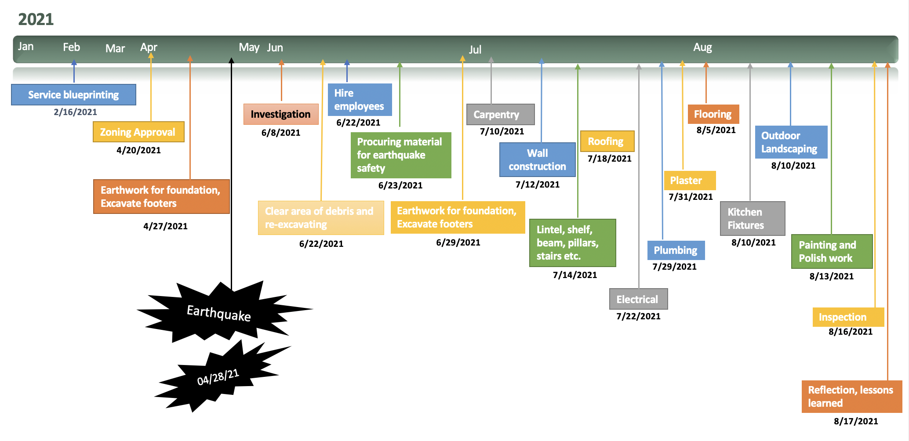

*Figure 22. Timeline after Natural Disaster (*[*larger view*](https://drive.google.com/file/d/1MXpaQuskCIupveBvB9RIBSRpeiNo7LW0/view?usp=sharing)*)*

# 

# Project Executing

## Technical Challenges

### Bureaucratic Challenges

Whenever a new housing project plan comes up there are always some groups which will lobby against that plan. There may be many reasons for this, sometimes people don’t want their area to be overcrowded so their representative(mayor) will lobby against such plans on new housing projects. So due to disapproval from certain sections of society getting a license/permit will be difficult.

### Environmental Challenges

If there are new development projects, there will be more people, more vehicles, more shops which may result in cutting down of trees and hence cause environmental issues.

### **Space Issues**

Some cities like San Francisco are already over crowded and hence there is no space for new housing projects as we can see in SF, there are already so many homeless people but it has been impossible to house them all.

### Crime Issues

There are some areas people would not want to move in since these areas might already be black listed as crime areas where people will not move in even if there are housing available. Usually people with families and with small kids will not want to move in such areas.

### **Unsuitable Areas**

Some areas will be unsuitable for development because of proximity to the ocean and other water bodies. These areas will be on the radar of flooding in these times of Global Warming plus it is difficult to develop new housing projects in mountainous areas due to the steepness or incline. Also other areas will be unsuitable because they are in desert areas so there will be shortage of water.

### Commute Challenges

Commutes should be doable otherwise people will not want to move in the new housing project. If the walk score is good, usually the night life will be good otherwise young people might not want to move in. For Example- SF has a very good walk score. In U.S. cities, homes within walking distance to jobs, schools, shopping, parks and other urban amenities are both highly desired and extremely rare. And like everything rare and desirable, walkability comes at a premium; homes highly “walkable” to amenities, everything else being equal, are more expensive than comparable homes in less “walkable” areas.

People are opting to move nearby, even closer to the restaurants and bars they love walking to, rather than move out to bigger homes.

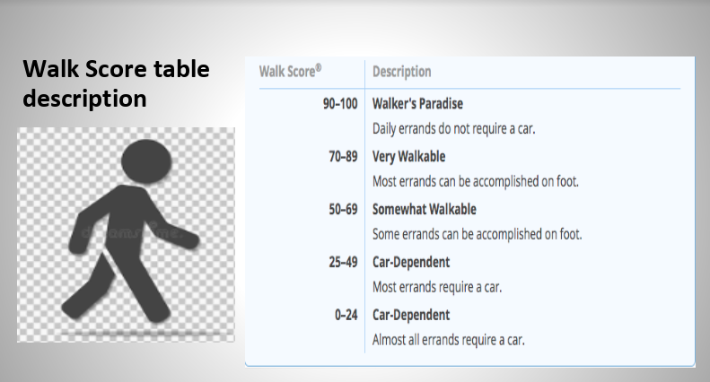

*Figure 23. Walk Score Table Description*

## 

## Risk Management: Scenarios & Risks

### Numerical Scale

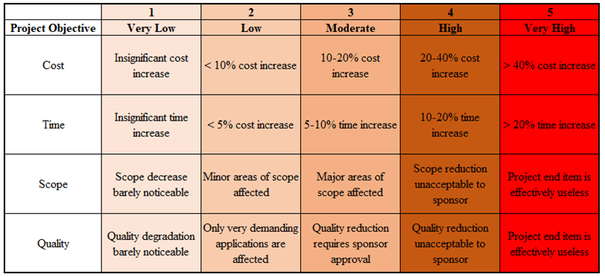

*Figure 24. Numerical Scale*

In order to perform our risk assessment, we established criteria and metrics to measure each potential risk. While our risk assessment is variable and could change based on either controllable or uncontrollable factors, risk scoring potential impacts will allow us to place estimated bookends on worst case scenarios when it comes to project duration or project cost.

The above risk scale grades the impact on 4 project objectives (cost, time, scope and quality) from very low (1) to very high (5). In the body of the chart are thresholds that will assist in scoring the impact of each risk that will be identified in the risk assessment form. Please refer to the risk assessment form below for further information.

### 

### Initial Risk Assessment Form

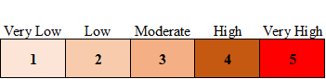

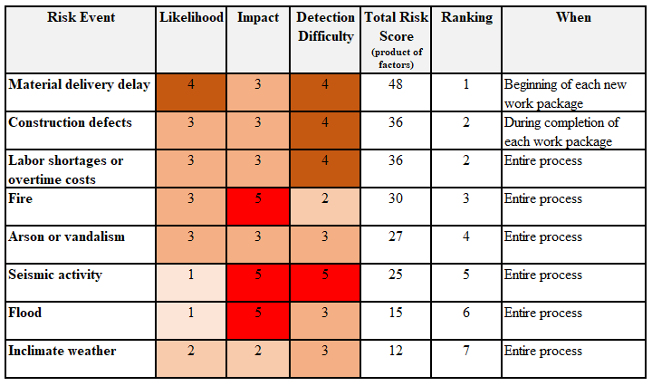

*Figure 25. Initial Risk Assessment Form*

Our initial risk assessment form at the beginning of our project planning process is shown above. It appears that material delivery delay is our highest risk event with a risk score of 48. Construction defects and labor shortages / overtime costs are the second highest risk events with scores of 36. Fire is the third highest risk event with a score of 30. It is interesting to note that natural disasters and acts of nature events such as inclimate weather, seismic activity and flood events are the least likely to occur. However, it should be noted that fire, seismic activity and flooding have the highest potential impact despite being among the least likely events.

### 

### Underground Secrets

Upon exacativing and leveling the ground in preparation for pouring the concrete foundation slab, the excavation team discovered a subterranean cavern 10 meters below the surface. Geologists from the University of California were called to investigate the cavern and discovered a previously undiscovered fault line. The geologists brought equipment and recommended pausing the construction site for two weeks in order to perform documentation of the cavern and form recommendations as to the safety of the construction site above. The geologists eventually declared that the bedrock and structural formation underneath did not pose a long-term threat to the construction site. Unbeknownst to the general contractor and developers, the discovery of the fault line and associated caverns were an ominous foreshadowing of things to come.

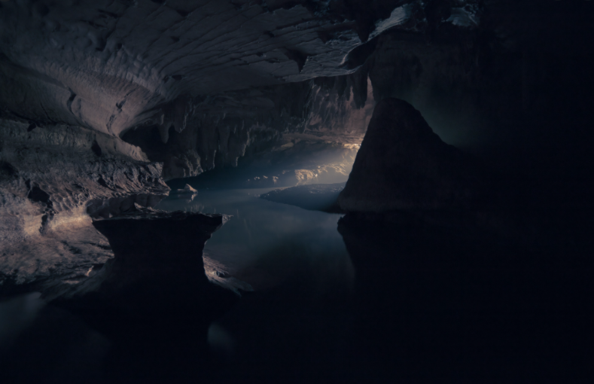*Figure 26. Underground Secrets*

### 

### Risk Assessment Form - Post-cavern / fault discovery



### 

*Figure 27. Risk Assessment Form - Post-Cavern*

As a result of the discovery of underground fault lines, the risk assessment form was updated in order to reflect additional risk from seismic activity. The likelihood of a future seismic event could be simply put, “as not if the event would happen, but when.” As such, the seismic activity likelihood score was increased from 1 (very low risk) to 4 (high risk). This adjustment moved seismic activity risk from the 5th ranked risk event to the highest ranked risk event. As such, our project team developed a much more in depth contingency plan, code named Plan Delta, in order to address, mitigate and avoid risk if possible. As we continue to move forward with the project, there is a level of acceptance that a seismic event could occur. We know we are building on an earthquake prone area, but will accept the risk due to the demand of housing in the area.

### Risk Response Outline

* **Mitigating Risk:** reduce likelihood an adverse event will occur
  + Strengthen structural design and implement stronger and earthquake resistant methods
* **Avoiding Risk:** changing the project plan to eliminate risk
  + We cannot eliminate risk
* **Transferring Risk:** paying premium to pass the risk to another party
  + Earthquake insurance and building insurance
* **Accepting Risk:** making a conscious decision to accept risk

### Risk Severity Matrix

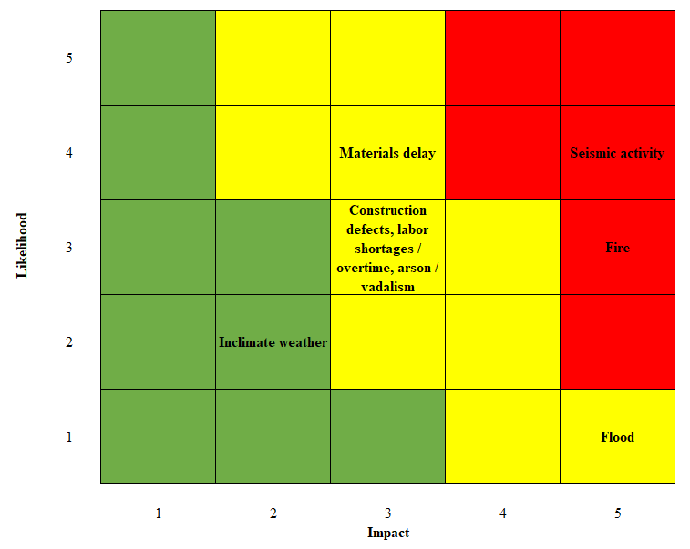

*Figure 28. Risk Matrix*

According to the risk severity matrix, seismic activity is the highest risk event. As such, we will focus on developing a contingency plan related to the risk of a seismic event occurring.

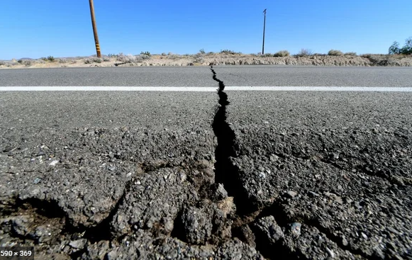

*Figure 29. Seismic Event*

### Contingency Plan Activation: Plan Delta

A “contingency plan” is an alternative plan that will be used if a possible foreseen risk occurs. Due to the discovery of the underground caverns and fault lines, we developed a contingency plan in the event an earthquake would result in damage. It was a fortuitous and timely discovery as the team felt better prepared and equipped to respond to the earthquake disaster. As illustrated above, our project experienced a major setback in that a 7.7 magnitude earthquake hit the SF Bay Area. The following events are the contingency plan that we developed in order to mitigate the effects of a potential earthquake.

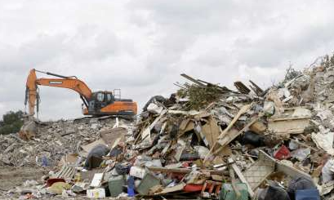

*Figure 30. Earthquake Disaster Aftermath*

### Plan Delta Executive Summary

1. Investigate the damage caused by the earthquake
2. Clear area of debris
3. Begin the reexcavation process
4. Procure the materials needed to redevelop the building
5. Hire the necessary amount of employees needed to complete the project in a reasonable timeframe
6. Develop a schedule to quantify the amount of employees needed to work weekends
7. Begin the rebuilding process from step 1.3 Earth Work for Foundation
8. Excavate footers with new earthquake safety in mind
9. Adhere to the WBS in order to meet all of the deliverables and sub deliverables in place prior to the risk event

The execution of this contingency plan impacted the overall timeline of the development of the affordable housing project approximately 5-6 months as more thoroughly described in the “Contingency Considerations and Estimated Impacts” segment of this report.

### Contingency Considerations and Estimated Impacts

The earthquake event would cause at worst a 5 to 6 month delay due to immediate lack of materials, labor, disruption of supply chain and reassessment of building plans for safety. Below is an outline of these contingency plan considerations.

* Potential project duration impacts
  + Geological and zone safety investigation and reassessment: *1 month* 
    - Root cause analysis, prevention in the future - are current plans adequate to withstand the next big earthquake?
    - May need additional frame strengthening / beam tie-downs and isolation of building frame from ground motion
  + Supply chain and labor pool normal resumption: *3 months*
  + Clearing area of debris and re-excavating: *1 week*
  + Rebuilding from step 1 with new earthquake safety in mind: *4 weeks*
    - Normal conditions: Foundation: *5 days delayed*, Framing: *~5 days*
* Potential project cost impacts
  + Increased materials costs by 10% due to expedite shipment
  + Additional 10% labor costs due to extra workers and weekend work
  + Rent crane to remove debris $375/hr, extra wages for workers (hourly)
  + Earthquake material (isolated material): standard cost $3-7K depending on how many units
  + Additional earthquake permit fee: $400 ~9%, 1 week
  + Cost city will pay some - 1 week delay, we would have to pay our footage (square feet)
  + Hurt worker: hire new employee, workers comp, increase cost

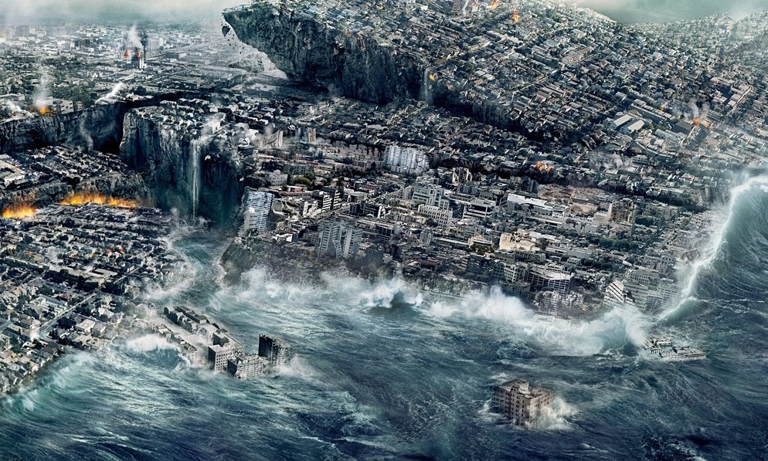

*Figure 31. A Sleeping Earth Awakens*

### A Sleeping Earth Awakens

Unfortunately, one week later on April 28, 2021, during the framing installation phase, an earthquake with a magnitude of 7.7 on the Richter Scale struck the nearby area. This was the largest earthquake on the West Coast since the Great San Francisco Earthquake of 1906. The framework that had been erected collapsed. The several days of site work that had already occurred would need to be redone from scratch. Additionally, more time and funding would be required to clean the site of construction debris and potentially rebuild using more earthquake resistant materials. An independent earthquake investigation would need to take place to ensure that the site would be safe to build on. Compounding the specific worksite issues would be constraints surrounding the availability of materials and labor following such a natural disaster. It could be months before normal supply chains and labor pools return to normal. In the interim, costs for materials and labor would be driven up significantly due to high demand. The original project schedule would need to be reassessed as it would appear the original project completion date may no longer be achievable.

Based on our contingency plan, contingency considerations and estimated impacts, our project team will need to provide a revised WBS, project schedule, propose a new target date and target cost, and potentially develop strategies to reduce project duration in order to complete the project. Once devised, we will need to procure and deploy resources to implement our revised planned work activities.

An additional response to implementing our contingency plan would be to reduce project duration based on our post-earthquake WBS and project schedule, in an attempt to successfully complete the project by the completion deadline.

## Reducing Project Duration (Project Crashing)

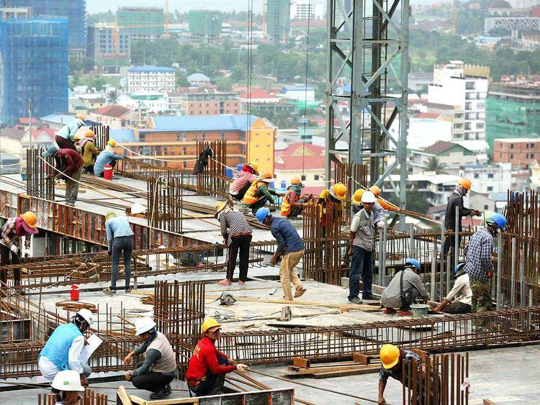

*Figure 32. Reducing Project Duration*

As we mentioned in the above sections that the deadline of this project of construction of affordable housing unit in the Bay area was September 1, 2021. As per our initial WBS, the expected date of completion was August 5th, 2021with the duration of 154.5 days.

Unfortunately, due to the occurrence of natural disaster the project completion date was pushed to October 26, 2021 with a duration of 212.5 days. So, this project was lagging behind by 56 days from the deadline of completion. Therefore, to complete our project within the timeline, our management decided to go with the reduction in the project duration (project crashing).

Project crashing was done by reducing the duration of the tasks which were included in the critical path by increasing the working days and adding the human resources. The workers were asked to work on the weekends on the basis of overtime wages. The tasks which were included in the crashing process were carpentry, lintel, shelf, beam, stairs, roofing, electrical, plumbing, plaster, flooring and outdoor landscaping.

So, the project was accelerated by **70 days** to meet the deadline. The date of completion of the project was August **17, 2021** with an additional cost of **$50,172**. Figure 33 below represents the tasks included in the crashing process with their normal cost and crash cost.

|  |  |  |  |  |  |  |
| --- | --- | --- | --- | --- | --- | --- |
| **Task No.** | **Task name** | **Predecessors** | **Normal time** | **Maximum crash time** | **Normal cost** | **Crash cost** |
| 1.1 | Service blueprinting |  | 33 days | 0 | 5039 | - |
| 1.2 | Zoning approval | Service blueprinting | 45 days | 0 | 3932 | - |
| 1.3 | Earthwork foundation, excavate footers | Zoning approval | 5 days | 0 | 150,404 | - |
| 1.4 | Investigation | Earthwork foundation, excavate footers | 30 days | 0 | - | - |
| 1.5 | Clear area of debris and re-excavating | Investigation | 14 days | 0 | 48,000 | - |
| 1.6 | Hire employees to work and perform over-time | Investigation | 14 days | 0 | 8464 | - |
| 1.7 | Procuring material for earthquake safety | Hire employees to work and perform over-time | 1 days | 0 | 17000 | - |
| 1.8 | Earth work for foundation, Excavate footers | Procuring material for earthquake safety | 6 days | 0 | 150,404 | - |
| 1.9 | Carpentry | Earth work for foundation, Excavate footers | 13 days | 2.5 | 14,504 | 18,976 |
| 1.10 | Wall construction | Carpentry | 2 days | 0 | 14000 | - |
| 1.11 | Lintel, shelf, beam, pillars, stairs, etc. | Wall construction | 7 days | 5 | 43,419 | 39,619 |
| 1.12 | Roofing | Lintel, shelf, beam, pillars, stairs, etc. | 8 days | 4 | 25,000 | 29,000 |
| 1.13 | Electrical | Roofing | 11 days | 7 | 16,000 | 30,000 |
| 1.14 | Plumbing | Electrical | 13 days | 6 | 19,400 | 28,000 |
| 1.15 | Plaster | Plumbing | 3 days | 1 | 32,700 | 45,000 |
| 1.16 | Flooring | Plaster | 9 days | 5 | 14,400 | 19,400 |
| 1.17 | Kitchen fixtures | Flooring | 5 days | 0 | 26400 | - |
| 1.18 | Outdoor landscaping | Kitchen fixtures | 6.5 days | 2 | 20,340 | 22,040 |
| 1.19 | Painting and polish work | Outdoor landscaping | 3.5 days | 0 | 13000 | - |
| 1.20 | Inspection | Painting and polish work | 1 day | 0 | 624 | - |
| 1.21 | Reflection, Lessons learned | Inspection | 1day | 0 |  |  |

*Figure 33. Normal Cost and Crash Cost*

In figure 33, all the tasks included in the project are shown with their normal and crash cost. The project was able to complete successfully before the deadline. But due to the earthquake and project crashing, there was additional cost on top of normal cost for some tasks. Some of the tasks were performed twice like Earth work for foundation, Excavate footers and some of them were additional tasks like clearing debris and procurement of materials for earthquake safety. There were few tasks with additional cost due to project crashing( mentioned below in the table). All of these activities increased our cost to a certain amount. So, the actual cost for this project was **$673,202** which is like $210,202 over budget.

|  |  |  |  |  |  |  |  |
| --- | --- | --- | --- | --- | --- | --- | --- |
| **Task No.** | **Task name** | **Predecessors** | **Normal time** | **Maximum crash time** | **Normal cost** | **Crash cost** | **Additional cost** |
| 1.9 | Carpentry | Earth work for foundation, Excavate footers | 13 days | 2.5 | 14,504 | 18,976 | **4,472** |
| 1.11 | Lintel,shelf,beam, pillars,stairs,etc | Wall construction | 7 days | 5 | 36,619 | 39,619 | **3,000** |
| 1.12 | Roofing | Lintel,shelf,beam, pillars,stairs,etc | 5 days | 1 | 25,000 | 29,000 | **4,000** |
| 1.13 | Electrical | Roofing | 11 days | 7 | 16,000 | 30,000 | **14,000** |
| 1.14 | Plumbing | Electrical | 13 days | 6 | 15,000 | 28,000 | **13,000** |
| 1.15 | Plaster | Plumbing | 3 days | 1 | 40,000 | 45,000 | **5,000** |
| 1.16 | Flooring | Plaster | 6 days | 1 | 14,400 | 19,400 | **5,000** |
| 1.18 | Outdoor landscaping | Kitchen fixtures | 6.5 days | 2 | 20,340 | 22,040 | **1,700** |
|  | **Total Additional cost** |  |  |  |  |  | **50,172** |

*Figure 34. Project Crashing with Additional Cost*

## Lessons Learned

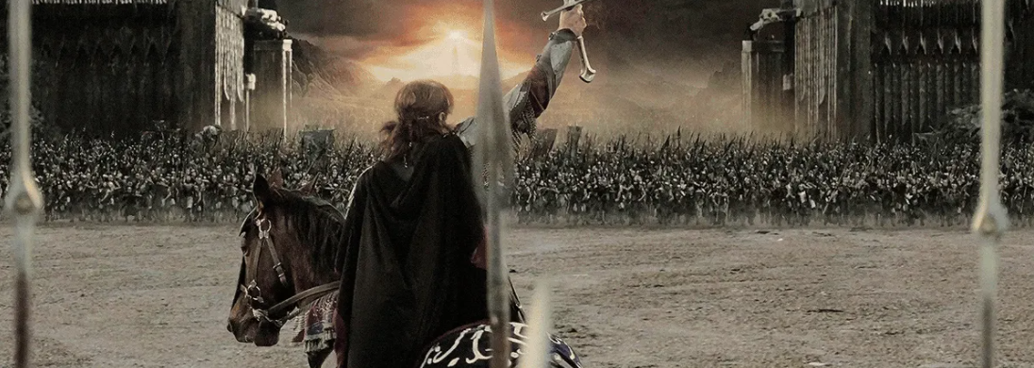

* “Short cuts make long delays.” ― J.R.R. Tolkien, The Fellowship of the Ring
* “When the pressure is on, you don't rise to the occasion—you fall to your highest level of preparation” ― Chris Voss
* “Persistence and resilience only come from having been given the chance to work through difficult problems.”― Gever Tulley

### 

### What did we do well?

Our team’s project to develop affordable housing units illustrated the importance of coordination, project planning and preparing for contingencies. We dealt with a complex and multidisciplinary project that required input from various stakeholders. Communication between team members to coordinate responsibilities was important. Without that coordination, we would not be able to produce detailed planning documents such as multiple versions of the WBS and project schedules. By spending time planning together, we were able to minimize any major confusion. Furthermore, by having the same understanding of project scope and what each of our team members duties were, we were able to optimize our work activities. Assigning work tasks and having defined roles is very important in having team-member buy-in and increases morale and project ownership.

Additionally, while we understood our project scope included a delivery date of February 16, 2021, we were able to achieve our project completion despite having major delays due to an earthquake. This is a testament to our project planning, contingency planning, disaster response and our creativity in project crashing.

Even with a major disruption such as an earthquake, our project team was able to crash the project in order to meet our original project deadline. Our team’s ability to adapt illustrated our team’s preparedness. With detailed planning completed , it was easier to make changes to specific activities whereas if we only planned at a high level, we would have a much more difficult time unpackaging and understanding what activities could be changed, crashed or combined. Additionally, our team’s risk assessment and contingency planning was well thought out and allowed our team to be responsive when an actual disaster occurred.

### What can we improve?

While we performed admirably in project planning, communicating and contingency planning, we could have done more due diligence up front to further study the historical impact of earthquakes in the area. While our team responded well to the discovery of underground caverns and a fault line by including much more detailed risk assessments and contingency planning, we could have consulted with local geologists and structural engineering specialists, pre-project, to understand the risks, potentially purchase more adequate insurance and include any potential recommendation in our initial building plans. While this would have increased the cost of construction and potentially increased project duration, it may have streamlined the implementation of our response and further strengthened our contingency plan.

Additionally, we did have to incur additional project costs and crashing costs due to the disaster. While it would be difficult to avoid increased costs under any natural disaster event, the increase in cost underscores the importance of having contingency planning funds and construction disaster insurance when available and if applicable.

# Conclusion

The team project was a success as the overall goal of “Affordable Housing for The Bay in 2022” was to develop affordable housing units by September 1, 2021. Although the team was setback 5 months due to the earthquake event occurring 10 months into the project, we were still able to manage completing the project before the February deadline. Through the utilization of advanced project management techniques, the team was able to develop a time scale horizon (WBS) in order to maintain the necessary planning and scheduling parameters, utilize a contingency plan to address the potential of unforeseen risks, and achieve these goals within budget all prior to the required deadline.

# Bibliography

REIDSteel.com, (2007) How to Make Buildings & Structures Earthquake Proof, Retrieved from <http://www.reidsteel.com/steel-buildings/resilient-steel-structures/earthquake-resistant-building/>

Larson, E. W., & Gray, C. F. (2018). Chapter 6: Developing a Project Plan. In *Project Management: The Managerial Process* (7th Edition ed., pp. 3-659). New York: Mcgraw-Hill Education.

Energy Star. “ENERGY STAR® Program Requirements for Residential Windows, Doors, and Skylights.” *Energy Star*, 2016, www.energystar.gov/sites/default/files/Windows_Doors_and_Skylights_Program_Requirements%20v6.pdf.

Google Drive for all Diagrams. <https://drive.google.com/drive/u/1/folders/1aFW8KYxMSob1ikfHf2jEqlGtPP_Dyvy8>

Google Drive for all our MS Project Files

<https://drive.google.com/drive/u/1/folders/1HsX6BRQRI8oDYxCPBHBrReUpi4x0Aa1U>